My Relevant application (Project Management/ Customer Interaction Application)

* I have already developed an application which is used for customer interaction. Customer creates a project in that application. This application has user interface to create projects.
* This application has interface to add stories for a project, under which a user can specify his requirements, more specifically in terms of tasks.

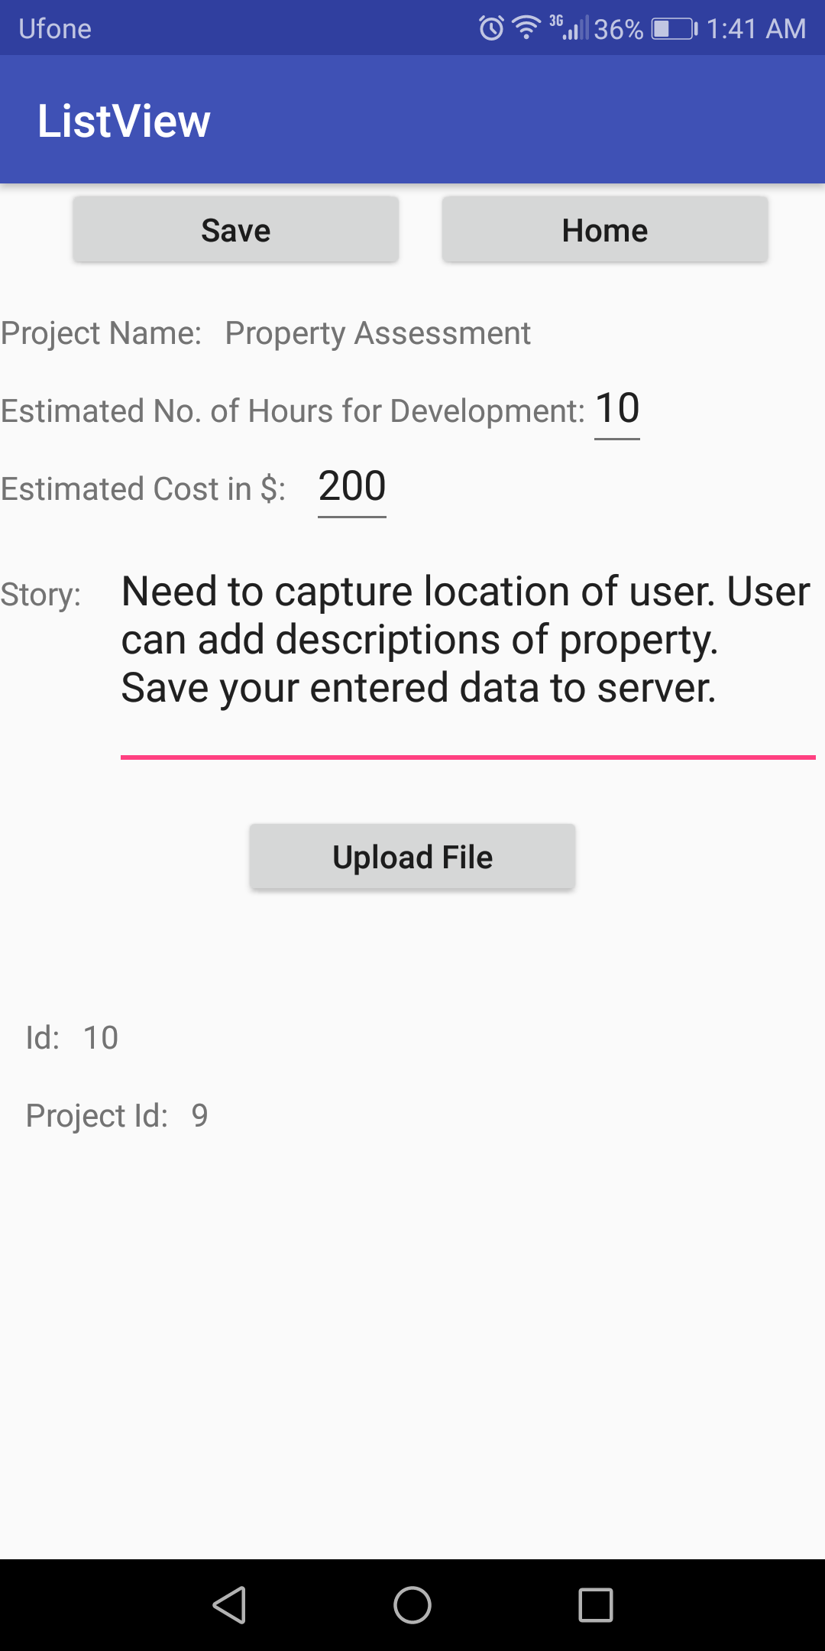

* This application has a listing page at which each project and its related stories can be viewed and can be selected for more details:

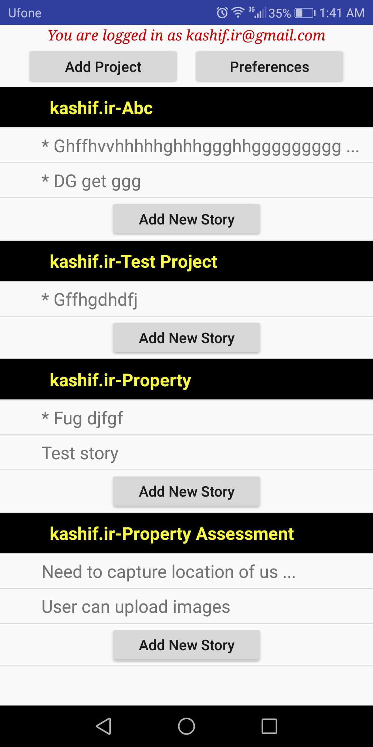

* It has a preferences interface where user preferences can be saved

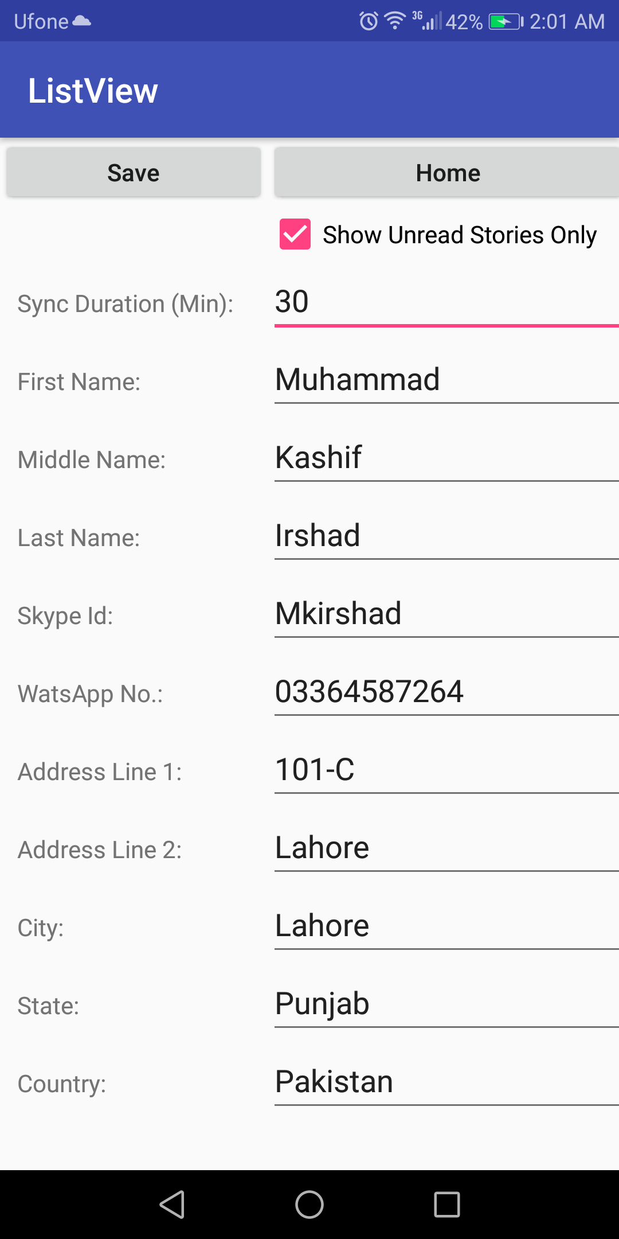

It also syncs data to and from server side in the form of JSON data requests.